**Name – Abhishek kumar**

**ROLL NO - 1901610100008**

**Implementation of Binary search**

#include<stdio.h>

#include<conio.h>

int main(){

int a[100],n;

printf("enter no. of elements\n");

scanf("%d",&n);

printf("enter elements\n");

for(int i=0;i<n;i++){

scanf("%d",&a[i]);

}

printf("enter search element\n");

int s;

scanf("%d",&s);

int first=0;

int last=n-1;

int middle=(first+last)/2;

while(first<=last){

if(a[middle]<s){

first=middle+1;

}

else if(a[middle]==s){

printf("position:%d",middle+1);

break;

}

else{

last=middle-1;

}

middle=(first+last)/2;

}

if(first>last){

printf("not found");

}

}

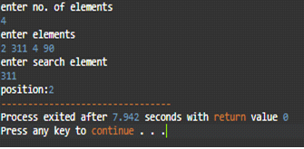output

**Implementation of Linear search**

#include<stdio.h>

#include<conio.h>

int main(){

int a[100],n;

printf("enter no. of elements\n");

scanf("%d",&n);

printf("enter elements\n");

for(int i=0;i<n;i++){

scanf("%d",&a[i]);

}

printf("enter search element\n");

int s;

scanf("%d",&s);

int f=0;

for(int i=0;i<n;i++){

if(a[i]==s){

printf("position:%d",i+1);

f=1;

}

}

if(f==0){

printf("element not found");

}

return 0;

output

}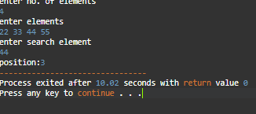

**Write a program in c to perform traversal of an array**

#include<stdio.h>

#include<conio.h>

Void main()

{

Int n, i ,a[i];

Printf(“enter the limit of array\n”);

Scanf(“%d”,&n);

Printf(“enter an array\n”);

for(int i=0;i<n;i++){

scanf(“%d”,&a[i]);

}

Printf(“ your array \n”);

for(int i=0;i<n;i++){

printf(“%d”,&a[i]);

}

getch();

}

output

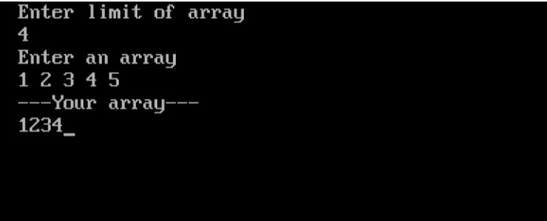

**Implementation of Insertion sort**

#include <stdio.h>

int main()

{

int a[100],m,n,temp=0,j;

printf("enter the size of array\n");

scanf("%d",&m);

printf("enter elements\n");

for(int i=0;i<m;i++){

scanf("%d",&a[i]);

}

for(int i=1;i<m;i++){

temp=a[i];

for(j=i-1;temp<a[j]&&j>=0;j--){

a[j+1]=a[j];

}

a[j+1]=temp;

}

printf("sorted array is\n");

for(int i=0;i<m;i++){

printf("%d ",a[i]);

}

}

Output

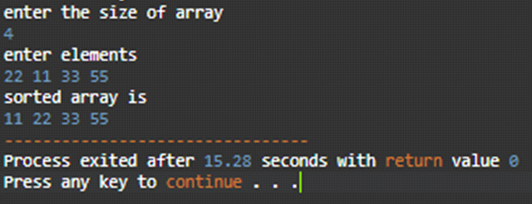

**Implementation of Selection sort**

#include<stdio.h>

int main()

{

int a[100],n,min,minIndex;

printf("enter no. of elements\n");

scanf("%d",&n);

printf("enter elements\n");

for(int i=0;i<n;i++){

scanf("%d",&a[i]);

}

for(int i=0;i<n;i++){

min=a[i];

minIndex=i;

for(int j=i+1;j<n;j++){

if(a[j]<min){

min=a[j];

minIndex=j;

}

}

a[minIndex]=a[i];

a[i]=min;

}

// printing of sorted final array

printf("sotred array:\n");

for(int i=0;i<n;i++){

printf("%d ",a[i]);

}

}

output

